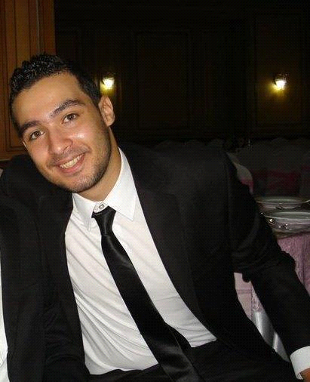
EHAB MOHAMMED SAEED
Personal Info:
Mobile: 01026662332
Current Address: 8 Seiag Towers - El Mariotia - Haram - Giza
E-mail: Mr.ehab.mohammed@gmail.com
Date of Birth: 10-Jan-1991
Military Service Status: Completed
Driving License: Valid
Career objectives:
Seeking a challenging position in a competitive Corporation, or a Company where I can Enhance and utilize my experience and personal skills.
And Finding a suitable position in a reputable or Organization, where I can put my skills Education and experience to work in a Healthy atmosphere, and be able to make my way up the corporate ladder.

Education Background:
- Secondary: Graduated from secondary school with grade: 94%.
- University: Cairo university, Faculty of Commerce-English section
- Grade: Bachelor degree with grade: Fair (D)
- Graduation Year: 2013

Experiences:
- Worked at 24-7 Tourism company as a Sales Representative and marketing (2008-2011)
- Worked at Azadya company (Virgin Mega Store) as a Sales Representative for 6 months.
- Worked at Telemarketing company as a Telesales from (2013-2014).
- Worked at IBEX Solutions Company as a Sales Representative for 6 months.
- And joined OSN Company as a Sales Outdoor for 3 months.
- Working Now at Falcon Group as Sales and Marketing Executive.

Courses:
- Dec. 2006, students skills development program (SSDP) certified recruitment and training committee (RTC)
- In Process of CIA ( Certification of Internal Audit )

Computer Skills:
- ICDL course
- Office application(Word, power point, Excel ) Good
- Perfect user of internet including E-Mail, internet surfing.

Soft skills:
- Interactive and fast enough to learn new technologies and sciences.
- Able to work in group, under pressure, manage stress, teaching others, helpful, creative and calm.
- High Communications Skills.
- Self-Motivated.
- Ability to meet deadlines successfully maintaining the quality of work.

Languages:
- Arabic: Mother Tongue.
- English: Very Good.
- Dutch: Fair

Thanks,

